2018380039_Dikshya Kafle Multimedia_Research and Training





2028380039_Dikshya Kafle **Dissertation of Multimedia**

**How Will the AI Technology be Applied in the Future Multimedia Applications:  
  
Keywords: AI, Future, Mutimedia, Application**

**Introduction:**

The technology is alternating our existence with its revolutionary speed and responsiveness. The multimedia area encompasses a wide range of science and technology aimed at creating solutions for both individual disciplines and multidisciplinary fields. The medium that disseminates knowledge interactively, and incorporates two or more media, is multimedia. As shown in Figure1, text, sound, image, video, and so on can be processed and transmitted. Because of scientists' innovation and imagination and software creation, more high-tech gadgets and multimedia tools are developed and distributed to users with computer help.

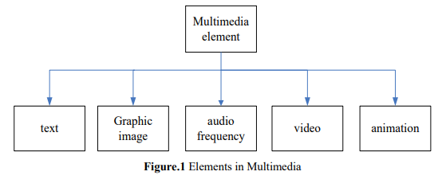Multimedia research has used Artificial Intelligence (AI) techniques from the beginning to tackle different challenges in this field. In particular, for multimedia retrieval, management, and analysis, AI has been widely used. Multimedia has continued to use AI over the past few years to bring groundbreaking development in various applications and fields, largely due to the recent advances in machine learning algorithms and computational forces. However, there are still many challenges that call for the need to expand Multimedia AI to address these issues and lead to incredible openings within close future.

The goal of the paper is to understand potential developments in AI technology and their increasing effect on multimedia applications. Artificial Intelligence is driven by multimedia to undergo a paradigm change towards more transparency. In essence, artificial intelligence injects new ways of thought into multimedia studies.[1]The following questions are answered in this paper: In the next years, how can AI change creative multimedia? The goal of this paper is to provide a practical view of the scope of AI activities in creative industries, to suggest a vision of how this technology could contribute to the work of research and development in this context, and to identify the challenges of research and development.

**AI in Multimedia Technology:**

The essential growth brought about by multimedia & AI technologies has been recommended in recent years. Due to the enormous presence of multi-model sensors and smart objects in the environment, increased multimedia collaboration between various organizations and real-time media sharing between socially connected individuals, multimedia plays a dynamic role in the smarter city eco-system. In this scenario, cloud computing events fit well with technology as it offers a flexible stack of low-cost computing, storage and software services. As a consequence, we are witnessing a normal shift to multimedia cloud computing. The mobile device of the end user is used as an interface to access those services where the computationally demanding components of multimedia systems, services and applications move to the cloud.

**THE FUTURE IS NOW: AI'S IMPACT IS EVERYWHERE:**

More than anything in the history of civilization, [AI] is going to change the universe. More than electrical power.[2] Artificial intelligence impacts almost every business and every human being's future. Artificial intelligence has been the key catalyst of new technologies such as big data, robotics and IoT, and for the near future, it will continue to serve as a technical innovator.

There is practically no major modern AI industry that has not already been impacted by "narrow AI," which executes objective tasks using data-trained models and mostly falls into deep learning or machine learning categories. This is particularly true in the past few years, as the storage and analysis of data has increased dramatically thanks to robust IoT networking, smart system proliferation and ever-faster computer processing. [3]

Some industries are at the beginning of their journey through AI, others are veteran travelers. They've all got a long way to go. Nevertheless, it is impossible to disregard the impact artificial intelligence has on our current lives:

-**Multimedia in Education field:** With the aid of AI, textbooks are digitized, early-stage interactive tutors assist human teachers and students' feelings are assessed by facial recognition to help assess who is struggling or bored and further adapt the experience to their personal needs. The PC provides a high quality monitor for the use of multimedia as an education aid. All of this has encouraged a broad range of computer-based training to be created.

The burden and time spent on administrative work such as grading tests, documents and homework can also be removed or significantly reduced by AI, preparing lessons through configurable software that can create lesson plans and process and review scores. In addition, personalized and tailored teaching, tutoring, and learning will be improved by AI. Each child has specific educational needs, and individualized learning will meet those needs and enhance their overall academic success.[4]

However as we witnessed during the pandemic in 2020, individuals also want the human contact that they are offered by in-person classes. So while the interactive nature of education and online learning can and will be expanded by AI, students can find a new level of in-person social interaction to boost their educational experiences.

Therefore, the future of the education system will greatly increase classroom seats at a lower cost by remotely distributing 50 percent of the classrooms while working with technology companies to implement adaptive learning technology.

**-Multimedia in Advertising:** In ads, multimedia technology is widely used. Multimedia is used for the preparation of ads to support company and goods. Artificial Intelligence in the Entertainment area is used for marketing or buying and selling factors that include advertising, design, and movie promotion. The top advertisement and marketing solutions will come up with smart AI algorithms. With Artificial Intelligence, analytics can make all advertising processes quicker by way of using analytics.[5] In terms of answering audience objectives, designing advertising campaigns and making successful consumer solutions, AI-driven marketing software helps.

For instance, there is an excellent AI-based graphic design tool called 'Alibaba Luban' on the market. It is a wonder that it produces visual designs a hundred times faster than humans, which means that in just a second it can produce 8000 banners. Human beings cannot beat this incredible technology.[6]

It will change the advertising and marketing industries when artificial intelligence is completely operational. The way we think about new products and how to use them will be changed by synthetic personalities controlled by AI. The media ecosystem will be so fundamentally changed that it will be totally unrecognizable. The new standard would be customized programming and fully sensitive advertising. 5G will be the largest distributed AI rollout yet.[7]

-**Multimedia in Business:** The enterprise software of multimedia includes, product demonstrations, instant messaging. In industry, multimedia is used for training workers using projectors, presenting sales, educating clients, etc. Multimedia is used in the industry for teaching employees using projectors, presenting sales, educating customers, etc. A video will make a viewer come live.

Artificial intelligence has a wide variety of applications in industry. Indeed, most of us communicate on a regular basis with artificial intelligence in some way or another. They are becoming an imperative for companies that want to retain a competitive advantage as artificial intelligence technologies proliferate.[8] In systems that collect large quantities of data, machine learning is also used.

AI is beginning to make what was once thought impossible, like driverless cars, feasible.[9] In 12 developed countries, a report on the business effects of AI found that AI would increase productivity by 40 percent. AI is also expected to increase profitability in addition to competitiveness and improve customer services.[10] One of the maximum giant influences of AI on commercial enterprise is the massive takeover of mundane and repetitive jobs via robots. A survey of 3,000 managers across 21 countries showed that 83% of organizations today consider AI a strategic priority. IDC's projections also say that in 2021, global investment on cognitive and AI systems would hit $57.6 billion.[11]

-**Multimedia in Software:** From entertainment to interactive games, software developers may use multimedia on computers; it can be used as a learning process. Professionals and software developers generate this multimedia software. With the support of machine learning and deep learning technologies, AI software is used to build and create an intelligent application from scratch.

**Four types of AI software:**

**Artificial Intelligence Platforms:** This will provide the platform from scratch for designing an application. In this, several built-in algorithms are given. The Drag and Drop feature makes it quick to use.

**Chatbots:** This program will offer the impact that a person or entity is doing in a conversation.

**Deep Learning Software:** It involves recognition of speech, recognition of images etc.

**Machine Learning Software:** The technique that will make the computer learn from knowledge is machine learning.

-**Multimedia in Entertainment:** **The live internet pay to play gaming with multiple players has been popular in the recent days.** **In reality, the first multimedia device implementation was in the field of entertainment and in the video game industry as well.** **The combined effects of audio and video make different kinds of games more enjoyable.** **Many video games usually require joystick play.** **Multimedia is used in games for the most part. In video games, text, audio, pictures and animations are often used.** **Innovative and immersive games have been made possible by the use of graphics in games.** **It is additionally used for enjoyment in movies, in particular for the production of unique results in movies and animations.**

**AI will help create immersive content for AR / VR. Through using AI techniques, the film industry can do magic using AI techniques and create breathtaking scenes with a pair of goggles.**[12]

**Of course, user attention is drawn to the creation of virtual reality content for food shows, reality shows, and Artificial Intelligence-based live events / programs.** With all these advanced technologies, gazing indicates and films with real affect will not be a dream, it certainly takes place in the future.

**-Multimedia in Medicine:** **Multimedia use in medicine is increasingly growing.** **By looking at virtual surgery (simulators), physicians may be educated in medicine.** **Using multimedia, they will model how diseases transmitted by viruses and bacteria impact the human body and then develop techniques for developing them.**

**In medicine, there is already an enormous amount of technology and automation in play, whether we know it or not-medical records are digitized, appointments can be scheduled electronically, patients can use their phones or computers to sign in to health centers or clinics.** **When the use of technology in all aspects of life has grown, so has it quietly changed the ways in which we seek medical treatment.**

**Traditional careers such as medicine will be dismantled within decades, leaving most, but not all, practitioners to be replaced by less-experienced individuals, different kinds of experts, and high-performing systems.** **The use of AI alone can increase productivity and it also increases human performance when combined with AI.** **This hybrid model of people and machines working together offers a flexible paradigm of automation for medicine, one that generates new tasks and responsibilities for key practitioners in medicine and technology, expanding the capabilities of the whole field as we move forward.** **Machines are unlikely to substitute or eliminate the need for human doctors in the near future, and those already in or considering a medical career should be prepared to adapt, learn and develop alongside technological advances.**[13]

**-Multimedia in Research:** **We use multimedia to explore the invention and philosophy of various individuals or to create a prototype.** **Multimedia can also be used to discover the materials available on the internet.**[14]

**With an emphasis on automation of research techniques, the application of AI in research has evolved tremendously from creating a hypothesis to conducting experiments.** **Indeed, in biomedical sciences, medication combinations, and predicting diseases using AI, researchers are now able to solve complex problems.**[15]

**-Multimedia in Communication:** **In today's world, multimedia plays a vital role because society presently all are the things is keeps up with the instances. In multiple formats, multimedia communication involves displaying information. The interactive media could be a great way for communication since that can simple to communicate and get it what they say.** **There is animation, music, video, and all of this in multimedia after that.**

Today, on the basis of that information, the amount of data generated by humans and machines far outweighs the ability of humans to absorb, perceive and make complex choices. Artificial intelligence is the cornerstone of all machine learning and it is the long run of all advanced decision-making.[16] The most important factor in idea formation and efficiency is contact today. While AI occurs more often when dealing with contact between companies and customers, communication within the workplace is often transformed.[17]

It already automates manual and repetitive assignments. It'll soon increase human choices. It would, along the way contribute more to global GDP by 2030 than China and India's current production combined. That growth would be more than sufficient to generate many good jobs, while at the same time changing the way current jobs are done.[18]

We might be able to interact in the near future by transmitting our thoughts directly into the brain of someone else via a network. We are decades away from technologies like this but scientists are working to build brain-machine interfaces that allow people to directly transfer thoughts to a computer. Maybe in 50 years, we'll all be using an electronic form of telepathy.[19]

**Conclusion:**

For machines that can think, act, and perform jobs like humans, without human interference or feedback, AI is an umbrella term. Often all AI devices work using various levels of machine and deep learning technology with greater precision, accuracy and performance.

Often all AI devices work using various levels of machine and deep learning technology with greater precision, accuracy and performance. AI is everywhere around us and though many people are ignorant to it is incorporated into our everyday life.

With the rapid advancement of information technology, the demand for multimedia technology is becoming more and stronger in all walks of life. All sorts of new ideas and innovations can be implemented and continue to grow and innovate in multimedia technology. In its apps, multimedia will enhance users' lives. The most critical one is changing today's lifestyle. There'll be a number of colorful interactive apps in the future. Multimedia technology in the classroom, and mutual impact of education and teaching, mutual advancement, training of various technological talents for the new century, these abilities can advance the persistent advancement of mixed media innovation, and continuously shape a high-minded circle.

There have been questions about some detrimental effects that AI may have on ethics, equity, justice, and democracy, despite the tremendous benefits that AI technology provides. AI technology and devices actually wield tremendous power and influence over human lives. They set guidelines that we must obey and are used by major technology firms to track and collect data on people's lives. Some believe that these companies that control AI technologies will use acquired knowledge in the future to adversely convince, influence and exploit everyone else. Research on artificial intelligence, while far from achieving its height, already gives us glimpses of what an AI-dominated future may look like. Although a positive lens should show the rapid advancement of technology, it is important to exercise some caution and enforce worldwide regulations for the advancement and utilize of AI innovation.

**Figures:**

A huge larger part of respondents to a later WAN-IFRA study says that when it comes to creating and distributing interactive media content, AI and computerization will play a critical or exceptionally vital part within the future.

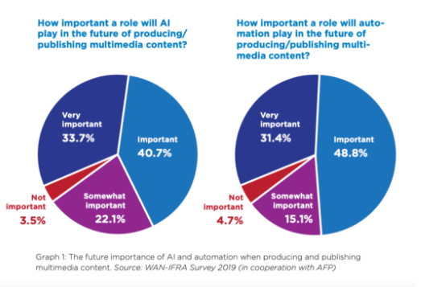**[20]**

The global demand for artificial intelligence applications is expected to grow from 9.5 billion U.S. dollars to 118.6 billion by 2025, according to Statista. The revenue reflects AI's fast growth and popularity.

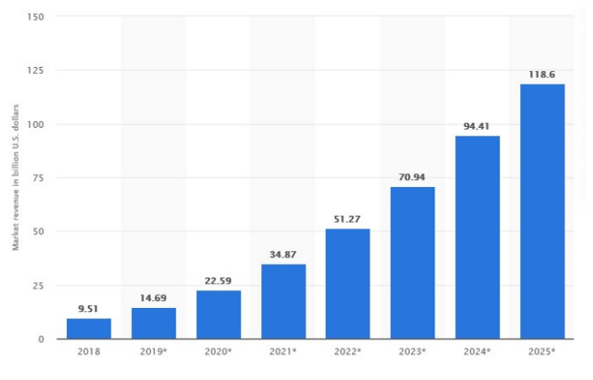

[21]

With the growth in this age of artificial intelligence, and its convergence with various industries such as banking, healthcare, e-commerce cannot be ignored. This technology has also been exploding in the media and entertainment field.

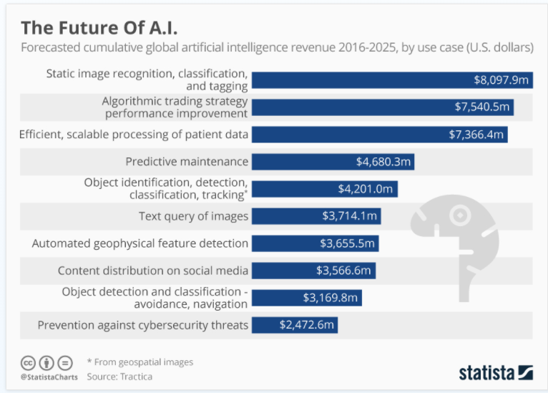[22]

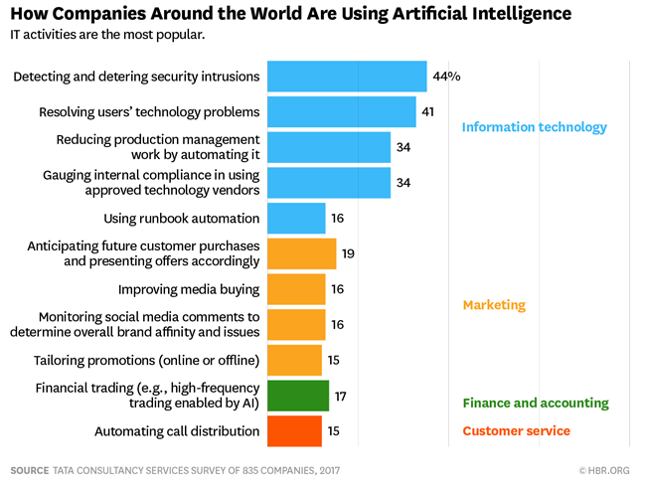[23]

**References:**

1. Thomas, M., 2020. *The Future Of Artificial Intelligence*. [online] Built In. Available at: <https://builtin.com/artificial-intelligence/artificial-intelligence-future> [Accessed 11 November 2020].
2. Nem-initiative.org. 2018. *ARTIFICIAL INTELLIGENCE IN THE MEDIA AND CREATIVE INDUSTRIES*. [online] Available at: <https://nem-initiative.org/wp-content/uploads/2018/10/nem-positionpaper-aiinceativeindustry.pdf> [Accessed 11 November 2020].
3. Johari, A., 2020. *Top 10 Real World Artificial Intelligence Applications | AI Applications | Edureka*. [online] Edureka. Available at: <https://www.edureka.co/blog/artificial-intelligence-applications/> [Accessed 11 November 2020].
4. Murali, A., 2019. *AI: The Future Of Technology And The World*. [online] Medium. Available at: <https://towardsdatascience.com/ai-the-future-of-technology-and-the-world-86f59d0cf720> [Accessed 11 November 2020].
5. zhu, w., Wang, x. and Gao, W., 2020. *Multimedia Intelligence: When Multimedia Meets Artificial Intelligence - IEEE Journals & Magazine*. [online] Ieeexplore.ieee.org. Available at: <https://ieeexplore.ieee.org/document/8970556> [Accessed 11 November 2020].
6. Corral, P., 2020. *Artificial Intelligence Real Applications For Broadcast & Media Industries | VSN*. [online] VSN. Available at: <https://www.vsn-tv.com/en/artificial-intelligence-applications-broadcast-and-media/> [Accessed 12 November 2020].
7. Rose, S., 2020. *How AI Is Transforming Media And Entertainment Industry?*. [online] Medium. Available at: <https://codeburst.io/how-ai-is-transforming-media-and-entertainment-industry-e40b7f72e24d> [Accessed 12 November 2020].
8. Anisetti, M., Damiani, E., Jeon, G. and Kantarci, B., 2019. *“Artificial Intelligence In Deep Learning Algorithms For Multimedia Analysis”*. [online] Static.springer.com. Available at: <https://static.springer.com/sgw/documents/1652518/application/pdf/MTAP+CFP+-+1148.pdf> [Accessed 12 November 2020].
9. System, T., 2020. *The Applications Of Multimedia System*. [online] Ques10.com. Available at: <https://www.ques10.com/p/31904/the-applications-of-multimedia-system-1/> [Accessed 12 November 2020].
10. USM. 2020. *AI In Entertainment Industry :Top 4 Applications & Use Cases - USM*. [online] Available at: <https://www.usmsystems.com/ai-in-entertainment-industry-top-4-applications-use-cases/> [Accessed 12 November 2020].
11. Uzailko, A., 2019. [online] Businessnewsdaily.com. Available at: <https://www.businessnewsdaily.com/9402-artificial-intelligence-business-trends.html> [Accessed 12 November 2020].
12. Kullabs.com. 2020. *Application Of Multimedia | Notes, Videos, QA And Tests | Grade 8>Computer>Multimedia And Its Application | Kullabs*. [online] Available at: <https://kullabs.com/class-8/computer/multimedia-and-its-application-1/application-of-multimedia-1> [Accessed 12 November 2020].
13. Enago Academy. 2020. *Artificial Intelligence In Research And Publishing - Enago*
14. *Academy*. [online] Available at: <https://www.enago.com/academy/artificial-intelligence-research-publishing/#:~:text=Similarly%2C%20the%20application%20of%20AI,and%20predicting%20diseases%20using%20AI.> [Accessed 12 November 2020].
15. Mendeley Careers. 2020. *Artificial Intelligence In Medicine*. [online] Available at: <https://www.mendeley.com/careers/news/careers-jobs-field/artificial-intelligence-medicine#:~:text=future%20of%20doctors%3F-,What%20is%20AI%20in%20medicine%3F,of%20patients%20who%20require%20care.> [Accessed 12 November 2020].
16. Iopscience.iop.org. 2018. *Future Development Trend Of Multimedia Network*. [online] Available at: <https://iopscience.iop.org/article/10.1088/1757-899X/466/1/012080/pdf> [Accessed 13 November 2020].
17. W. Zhu, X. Wang and W. Gao, "Multimedia Intelligence: When Multimedia Meets Artificial Intelligence," in IEEE Transactions on Multimedia, vol. 22, no. 7, pp. 1823-1835, July 2020, doi: 10.1109/TMM.2020.2969791.
18. profile, V., 2020. *Future Of Multimedia*. [online] Irenecnh.blogspot.com. Available at: <http://irenecnh.blogspot.com/2009/08/future-of-multimedia.html> [Accessed 13 November 2020].
19. PwC. 2020. *How Will AI Change The Future Of Work?*. [online] Available at: <https://www.pwc.com/gx/en/issues/data-and-analytics/artificial-intelligence/future-of-work.html> [Accessed 13 November 2020].
20. Garden, H., HowStuffWorks, Tech, Electronics and Tech, 2020. *What Is The Future Of Communication?*. [online] HowStuffWorks. Available at: <https://electronics.howstuffworks.com/everyday-tech/future-of-communication1.htm> [Accessed 13 November 2020].
21. Workplace?, H., 2018. *How Will AI Impact Communication In The Workplace?*. [online] Nfon.com. Available at: <https://www.nfon.com/en/news/press/blog/blog-detail/how-will-ai-impact-communication-in-the-workplace#:~:text=Although%20AI%20appears%20most%20commonly,transforms%20communication%20within%20the%20workplace.&text=With%20scientific%20methods%20such%20as,and%20procurement%2C%20and%20to%20production.> [Accessed 13 November 2020].
22. Trecek, R., 2019. *Artificial Intelligence Is Completely Reinventing Media And Marketing.*. [online] Medium. Available at: <https://medium.com/id-in-the-iot/artificial-intelligence-is-completely-reinventing-media-and-marketing-d724c150ece3> [Accessed 14 November 2020].
23. Gaddam, D., 2020. *The Future Of AI: Impact On Education, Businesses, Workforce And Societies | The Ritz Herald*. [online] The Ritz Herald. Available at: <https://ritzherald.com/the-future-of-ai-impact-on-education-businesses-workforce-and-societies/#:~:text=In%20the%20future%2C%20AI%20technology,solutions%20to%20individual%20consumer%20needs.> [Accessed 13 November 2020].
24. Zhu, W., Wang, X. and Gao, W., 2020. [online] Available at: <https://www.researchgate.net/publication/338844912_Multimedia_Intelligence_When_Multimedia_Meets_Artificial_Intelligence> [Accessed 13 November 2020].
25. Armstrong, M., 2016. *Infographic: The Future Of A.I.*. [online] Statista Infographics. Available at: <https://www.statista.com/chart/6810/the-future-of-ai/> [Accessed 17 November 2020].
26. Bhattacharjee, M., Bhattacharjee, M., Monojoy BhattacharjeeA former TV news anchor and journalist, & A former TV news anchor and journalist. (2019, October 15). How AI can benefit resource-challenged newsrooms: WAN-IFRA report: What's New in Publishing: Digital Publishing News. Retrieved November 17, 2020, from https://whatsnewinpublishing.com/how-ai-can-benefit-resource-challenged-newsrooms-wan-ifra-report/

1. https://ieeexplore.ieee.org/document/8970556
2. https://builtin.com/artificial-intelligence/artificial-intelligence-future
3. https://builtin.com/artificial-intelligence/artificial-intelligence-future
4. https://ritzherald.com/the-future-of-ai-impact-on-education-businesses-workforce-and-societies/#:~:text=In%20the%20future%2C%20AI%20technology,solutions%20to%20individual%20consumer%20needs.
5. https://www.usmsystems.com/ai-in-entertainment-industry-top-4-applications-use-cases/
6. https://www.usmsystems.com/ai-in-entertainment-industry-top-4-applications-use-cases/
7. https://medium.com/id-in-the-iot/artificial-intelligence-is-completely-reinventing-media-and-marketing-d724c150ece3
8. https://www.businessnewsdaily.com/9402-artificial-intelligence-business-trends.html
9. https://www.businessnewsdaily.com/9402-artificial-intelligence-business-trends.html
10. https://ritzherald.com/the-future-of-ai-impact-on-education-businesses-workforce-and-societies/#:~:text=In%20the%20future%2C%20AI%20technology,solutions%20to%20individual%20consumer%20needs.
11. https://ritzherald.com/the-future-of-ai-impact-on-education-businesses-workforce-and-societies/#:~:text=In%20the%20future%2C%20AI%20technology,solutions%20to%20individual%20consumer%20needs.
12. https://www.usmsystems.com/ai-in-entertainment-industry-top-4-applications-use-cases/
13. https://www.mendeley.com/careers/news/careers-jobs-field/artificial-intelligence-medicine#:~:text=future%20of%20doctors%3F-,What%20is%20AI%20in%20medicine%3F,of%20patients%20who%20require%20care.
14. https://kullabs.com/class-8/computer/multimedia-and-its-application-1/application-of-multimedia-1
15. https://www.enago.com/academy/artificial-intelligence-research-publishing/#:~:text=Similarly%2C%20the%20application%20of%20AI,and%20predicting%20diseases%20using%20AI.
16. https://www.netapp.com/artificial-intelligence/what-is-artificial-intelligence/
17. https://www.nfon.com/en/news/press/blog/blog-detail/how-will-ai-impact-communication-in-the-workplace#:~:text=Although%20AI%20appears%20most%20commonly,transforms%20communication%20within%20the%20workplace.&text=With%20scientific%20methods%20such%20as,and%20procurement%2C%20and%20to%20production.
18. https://www.pwc.com/gx/en/issues/data-and-analytics/artificial-intelligence/future-of-work.html
19. https://electronics.howstuffworks.com/everyday-tech/future-of-communication1.htm
20. https://whatsnewinpublishing.com/how-ai-can-benefit-resource-challenged-newsrooms-wan-ifra-report/
21. https://codeburst.io/how-ai-is-transforming-media-and-entertainment-industry-e40b7f72e24d
22. https://www.statista.com/chart/6810/the-future-of-ai/
23. https://chatbotsmagazine.com/artificial-intelligence-ai-global-trends-how-the-businesses-can-benefit-ai-today-use-cases-9693c542099e